720 Roadside
www.720interdiction.com / mike@720interdiction.com / Phone: 361-510-1783
A DIFFERENT INTERDICTION TRAINING ORGINIZATION
- Trends come and go!
- ALPRS are a great tool but not every agency has one and someday this technology may become obsolete for law enforcement.
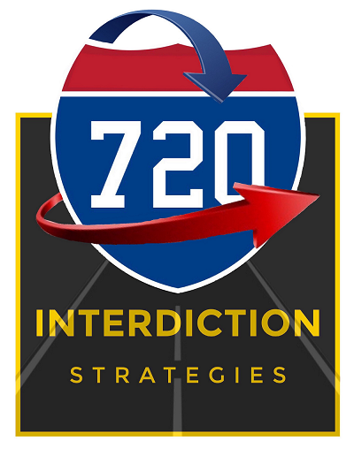
- Intelligence interpretation prior to a stop is great but not every officer has access to the software on their issued MDT (Mobile Data Terminal).

So, why choose the 720 Roadside? Simple, because we focus on ONE variable present during every single encounter with the motoring public; HUMAN BEHAVIOR.

- Can you imagine a strategy based 100% on communication that will take the guess-work out of criminal interdiction?
- Can you imagine a strategy that will eliminate the word “LUCKY” as a metric for success?
- Can you imagine a strategy that is built by a full-time criminal interdiction officer and vetted through HIS traffic stop body/dash cameras and not someone else’s?
- Can you imagine a strategy that has been successfully tested and vetted in State and Federal Court?
- Can you imagine a strategy that is developed with one goal, courtroom victory?
- Can you imagine a strategy that has application throughout the United States and does not standardize a concept that teaches you their, “way is the only way?”

If you can imagine any of those scenarios, then this is your course! Success in Criminal Interdiction is NOT gained by luck or chance, it is earned by understanding, recognizing and interpreting human behaviors. 720 Roadside is a methodology, based solely on human behavior interpretation, that will improve your observation skills to objectively, proactively and successfully hunt criminals. Our roadside strategy works because we apply the education of human behaviors to each stop. Once armed with this information, you will be able to quickly identify clues prior-to and during the traffic stop that will increase your probability of identifying crimes in progress. Through experience, we know the job isn’t finished unless we win in court, so 720 Interdiction Strategies will also provide you with knowledge necessary to defend your roadside actions and structure a solid impenetrable defense for your application of the methodology.
The 720 Roadside course covers all 720-degrees of a proactive interdiction traffic stop by starting with our Limbic Based Driving Behavior (LBDB) system. LBDB works because its framed around a motor vehicle occupant fearing consequences associated with law enforcement intervention. LBDB will not only show you how to successfully identify motorists involved in criminal activity but will also explain why the strategy’s effectiveness is rooted in human consequence guided behaviors.
Once an officer has correctly applied the LBDB system and a traffic stop is conducted, our REDE (Rapport Baseline Determine-relevance Behavior-Analysis) strategy can be employed to increase your ability to accurately identify verbal/non-verbal behaviors associated with individuals confronted with a consequence. REDE will provide you with an accurate assessment to guide your next decision; search or not to search. REDE is a process developed from many successful “real world” experiences, education and courtroom defenses. REDE can be successfully applied to all facets of law enforcement because it relies on exploiting human emotions associated with consequence. Whether a detective working a homicide, an Agent investigating terrorism or a uniformed officer conducting proactive interdiction, REDE will help you identify and articulate those behaviors which define and confirm your Reasonable Suspicion.
So, why choose 720 Interdiction Strategies? Because our ONLY goal is to make YOU successful!
Thank you for considering 720 Interdiction Strategies, we promise to make your training needs our priority,
Mike Tamez
Owner/720 Interdiction Strategies

