720 Concealment
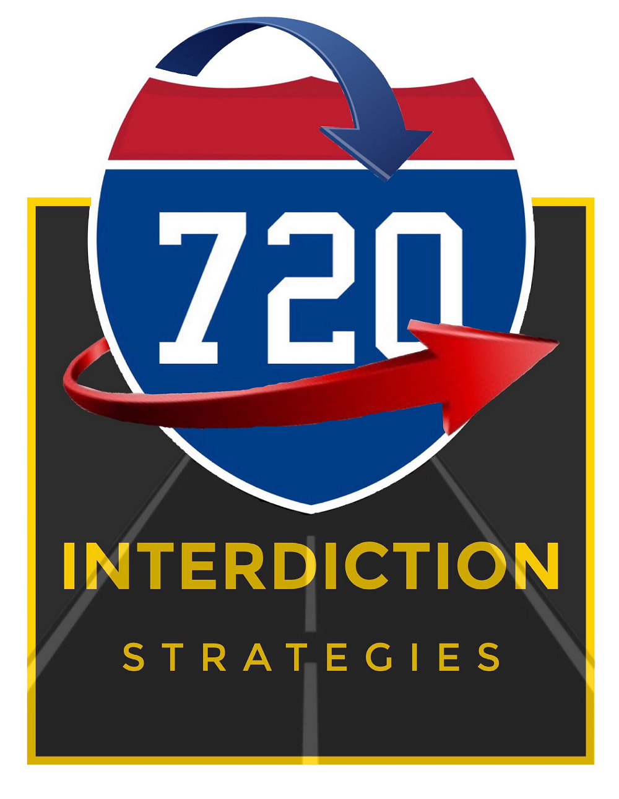
www.720interdiction.com / mike@720interdiction.com / Phone: 361-510-1783
A DIFFERENT INTERDICTION TRAINING ORGANIZATION
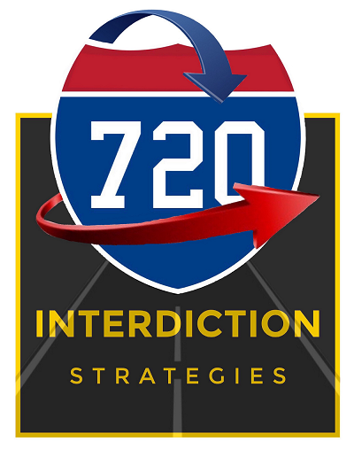
- Have you ever left a traffic stop wondering if you searched thoroughly?
- Have you ever seen so many clues of tampering on an engine, transmission, axle, dash, etc… but lacked the knowledge & confidence of how to search them properly?
- Have you ever been through a concealment class that left you confused and unfulfilled?
- Have you ever wanted to attend a concealment course that validates the instructor’s techniques from the optic of his body/dash during actual traffic stops?
If you can answer, “yes” to any of those question, then 720 Concealment is your solution!
So, why choose the 720 Concealment course? Simple, because we provide factual solutions to searching. 720 Concealment is truly the course that will translate your in-class education to roadside application. 720 Interdiction Strategies does not teach some techniques we’ve only heard about, we only teach what we’re willing to use ourselves.
So, what can you expect from this course?
- Video and photographs of the instructor applying the techniques we teach.
- 3 rapid assessment phases that will drive down your detention/search times.
- How to easily search deep concealments within a motor vehicle like:
- Tires
- Firewalls
- Rocker panels
- False floors
- Exhaust tunnels
- Dash
- ETC…
  - Multiple engine blocks
  - Transmissions
  - Axles & Differentials
  - A/C System
  - Oil pans
  - Gas tanks
  - Tires
So, what can you NOT expect from this course?
- Instructors trying to teach you from someone else’s hard work or material.
- Instructors occupying your valuable training time by bragging, boasting or showing, “trophy pics.”
- Instructor with a, “My way is the only way” mentality.
- Instructor who is placing his personal time ahead of your learning time.
720 Concealment is a course built for you by an instructor who previously had zero mechanical experience. Why is this important? Because the learning process has given your instructor a method of simplifying search techniques for deep concealments. Since you, the student, are the one who is out on our interstates and highways hunting criminals, we believe in doing the research and arming you with the most recent compartments being utilized by Drug Trafficking Organizations. With each concealment, you will see normal vs not normal, you will learn how to describe the concealment in a report and if applicable, how to apply technology like an x-ray imager and a scope.
So, why choose 720 Interdiction Strategies? Because our goal is to earn your trust by validating the efficiency of our strategies, so you may be successful.
Thank you for considering 720 Interdiction Strategies, we promise to make your training needs our priority,
Mike Tamez
Owner/720 Interdiction Strategies

